|  |
| --- |
| TEACHER’S COMMENTS & PARENT’S SIGNATURE |
| 1st Quarter |
| 2nd Quarter |
| 3rd Quarter |
| 4th Quarter |
| Teacher:  Principal:  School |
| Assigned to Grade _________________ for School year __________ |

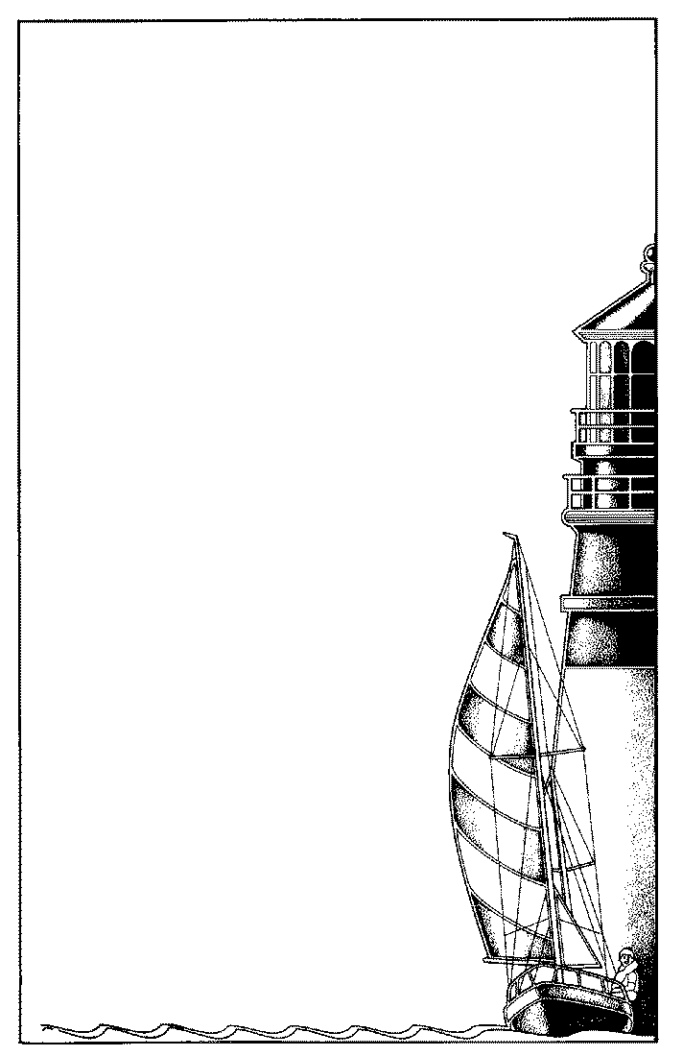

But the path of the Just is as a

Shining Light that shineth more and more unto the Perfect Day

Proverbs 4:18

**A Guiding Light to the Next Generation**

Student:

Grade:

Year:

**Seoul Christian School**

**Elementary**

**Progress Report**

|  |  |  |  |  |
| --- | --- | --- | --- | --- |
|  | **1** | **2** | **3** | **4** |
| **BIBLE** | A |  |  |  |
| Shows knowledge of Bible lessons | 1 |  |  |  |
| Applies Bible principles in work and play | 1 |  |  |  |
| Learns Bible verses | 1 |  |  |  |
| **ENGLISH** | B |  |  |  |
| Expresses ideas well orally | 1 |  |  |  |
| Communicates ideas well in writing | 2 |  |  |  |
| Writes with correct grammar | 3 |  |  |  |
| Writes with correct sentence mechanics | 1 |  |  |  |
| **HANDWRITING** | B- |  |  |  |
| Forms letters correctly | 1 |  |  |  |
| Writes neatly and legibly | 2 |  |  |  |
| **HERITAGE STUDIES** | A |  |  |  |
| Demonstrates skills with maps, graphs, and a time line | 1 |  |  |  |
| Evidences growth in historical knowledge | 1 |  |  |  |
| Participates in discussion and group activities | 2 |  |  |  |
| **MATH** | C |  |  |  |
| Understands and applies concepts | 1 |  |  |  |
| Knows math fact | 2 |  |  |  |
| Computes carefully | 3 |  |  |  |
| Uses logical thinking in problem solving | 1 |  |  |  |
| **READING** | B+ |  |  |  |
| Comprehends facts and details from silent reading | 1 |  |  |  |
| Evidences higher levels of comprehension from silent reading | 1 |  |  |  |
| Communicates meaning in oral reading (fluency, expression) | 2 |  |  |  |
| Demonstrates comprehension on worktext pages | 1 |  |  |  |
| **SCIENCE** | D |  |  |  |
| Demonstrates the use of the scientific process | 1 |  |  |  |
| Shows a growing awareness of scientific knowledge | 1 |  |  |  |
| Participates in discussion and group activities | 1 |  |  |  |
| **SPELLING** | C |  |  |  |
| Spells words with common spelling patterns | 1 |  |  |  |
| Applies spelling skills in writing | 2 |  |  |  |
| Demonstrates knowledge of dictionary skills | 1 |  |  |  |



Spiritual & Social Record

Academic Record

|  |  |  |  |  |
| --- | --- | --- | --- | --- |
| **RELATED ARTS** | **1** | **2** | **3** | **4** |
| Art | A |  |  |  |
| Music | A |  |  |  |
| Physical Education (TaeKwonDo) | A |  |  |  |
| Chinese | A |  |  |  |
| Computer | A |  |  |  |

and stature…

|  |  |  |  |  |
| --- | --- | --- | --- | --- |
| **MATURITY** | | | | |
| Shows age-appropriate maturity | 1 |  |  |  |
| Demonstrates self-control in speech and actions | 1 |  |  |  |

and in favor with **God**

and man.

|  |  |  |  |  |
| --- | --- | --- | --- | --- |
| **PERSONAL AND SOCIAL GROWTH** | | | | |
| Accepts responsibility | 3 |  |  |  |
| Is trustworthy | 2 |  |  |  |
| Interacts well with other children | 1 |  |  |  |
| Shows kindness and respect toward peers | 2 |  |  |  |
| Respects authority (obedient and cooperative) | 3 |  |  |  |
| Handles property responsibly | 1 |  |  |  |
| **WORK AND STUDY HABITS** | | | | |
| Pays attention in class | 1 |  |  |  |
| Participates in the learning process | 2 |  |  |  |
| Listens an follows directions | 2 |  |  |  |
| Completes work on time | 2 |  |  |  |
| Works well independently | 2 |  |  |  |
| Is neat and organized | 1 |  |  |  |
| **ATTENDANCE** | | | | |
| Days present | 40 |  |  |  |
| Days absent | 5 |  |  |  |
| Times Tardy  Grading Key |  |  |  |  |

|  |
| --- |
| A Excellent B Good C Average D Below Average F Unsatisfactory |
| 100-93 92-86 84-77 76-70 69-0 |
| 1 Very Good 2 Satisfactory 3 Needs Improvement 4 Unsatisfactory |